ASSIGNMENT 1

AIM 1:- Write an example of plot function which includes use of xlable, ylable, title and legend.

Code:-

figure

x = -pi:pi/20:pi;

plot(x,cos(x),'-ro',x,sin(x),'-.b')

hleg1 = legend('cos_x','sin_x');

Output:-

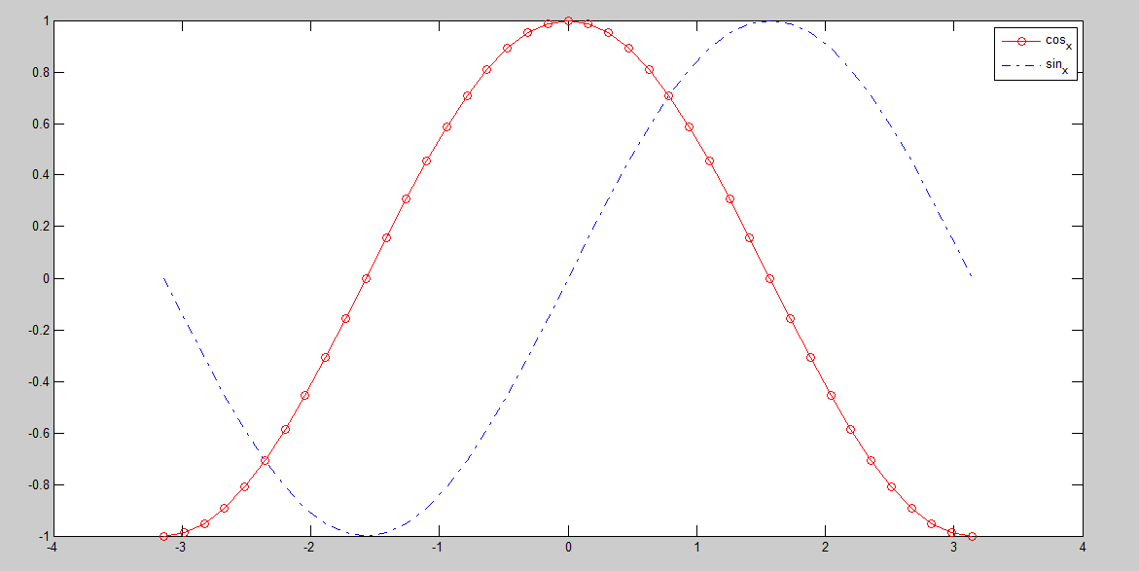

AIM 2:-Write a subplot function with example.

Code:-

x = [1:1:10];

y = x;

figure

subplot(2,2,1)

x = -pi:pi/20:pi;

plot(x,cos(x),'-ro',x,sin(x),'-.b')

hleg1 = legend('cos_x','sin_x');

subplot(2,2,2)

x = -pi:pi/20:pi;

plot(x,cos(x),'-ro',x,sin(x),'-.b')

hleg1 = legend('cos_x','sin_x');

subplot(2,2,3)

x = -pi:pi/20:pi;

plot(x,cos(x),'-ro',x,sin(x),'-.b')

hleg1 = legend('cos_x','sin_x');

subplot(2,2,4)

x = -pi:pi/20:pi;

plot(x,cos(x),'-ro',x,sin(x),'-.b')

hleg1 = legend('cos_x','sin_x');

Output:-

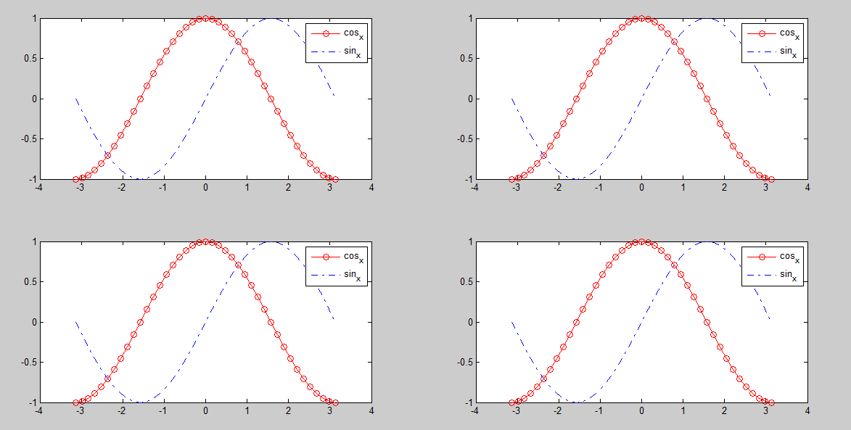

AIM 3:-Write Matlab programs which indicates use of if-else ,for and while loop.

Code:-

disp('Give the input 1.Example of if-else 2.Example of for loop 3.Example of while loop');

result = input('Enter Value of result')

if result==1

disp('THIS IS IF-ELSE');

elseif result==2

for i=1:10

disp('FOR LOOP');

end

elseif result==3

n=5;

x=1; i=1;

while i<=n

x=x*i;

i=i+1;

disp('WHILE LOOP');

end

fout = x;

else

disp('INVALID CHOICE');

end

Output:-

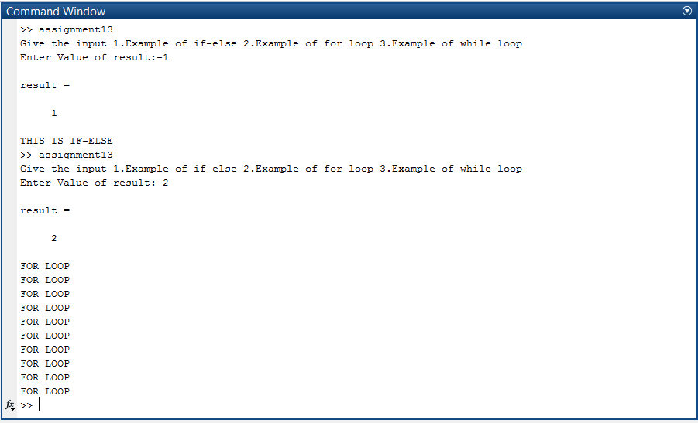

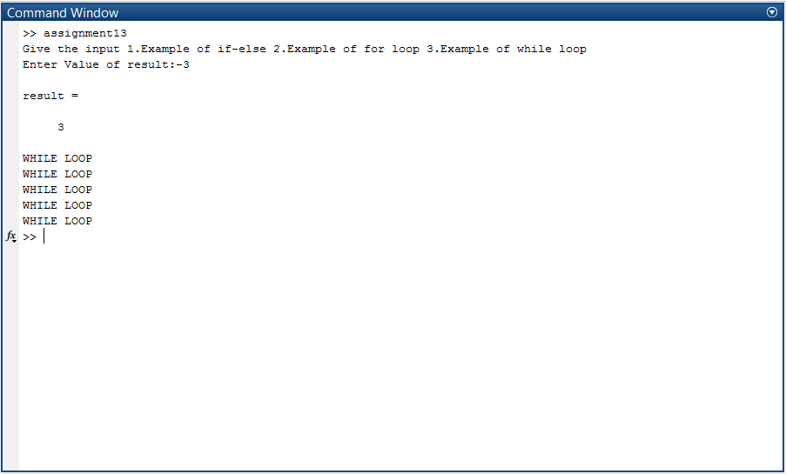

AIM 4:-Create Matlab function with your name which display your basic information. (eg. Name, surname, city, address, phone no).

Code:-

File content [from which function is to be called]:-

mudit()

File content [function defination]:-

function y = mudit( )

%UNTITLED Summary of this function goes here

% Detailed explanation goes here

disp('Name::Mudit');

disp('Surname::Dholakia');

disp('City::Rajkot');

disp('Address::8/1,Racecourse Park,Airport Road,Rajkot-360006');

disp('Phone::+919714345674');

end

Output:-

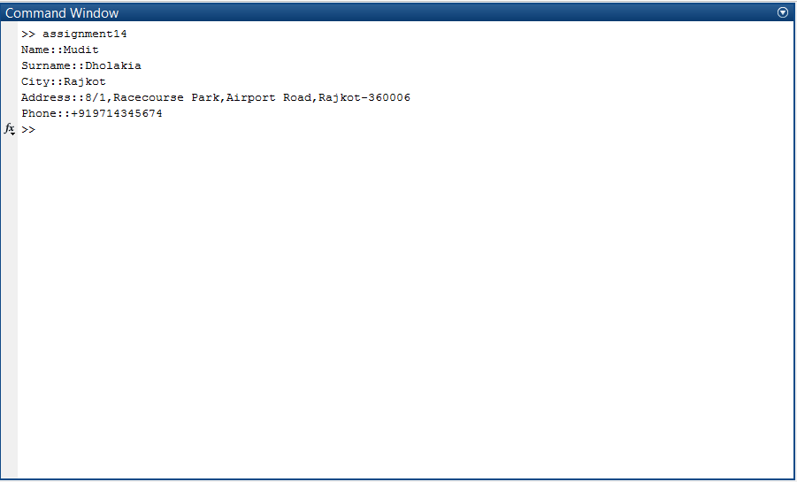

AIM 5:-Write a function to sort an array using yourname_sort function(x), where x is an array of numbers.

Code:-

File content [from which function is to be called]:-

num=input('ENTER THE NUMBER OF ELEMENTS TO BE SORTED:')

for i=1:num

disp('ENTER THE ELEMENT NUMBER:')

disp(i)

ip=input(':')

a(i)=ip

end

disp('For Ascending order press 1 for decending press 2:-->>ENTER:')

typ=input(':')

sorted=mudit_sort(a,num,typ)

disp('Sorted Sequence is:')

for i=1:num

disp(sorted(i))

end

File content [function defination]:-

function [ sorted ] = mudit_sort( array,ln,tp )

%UNTITLED4 Summary of this function goes here

% Detailed explanation goes here

if tp==1

for i=1:ln

for j=1:ln-1

if array(j)>array(j+1)

temp=array(j)

array(j)=array(j+1)

array(j+1)=temp

end

end

end

else if tp==2

for i=1:ln

for j=1:ln-1

if array(j)<array(j+1)

temp=array(j)

array(j)=array(j+1)

array(j+1)=temp

end

end

end

end

sorted=array

end

Output:-

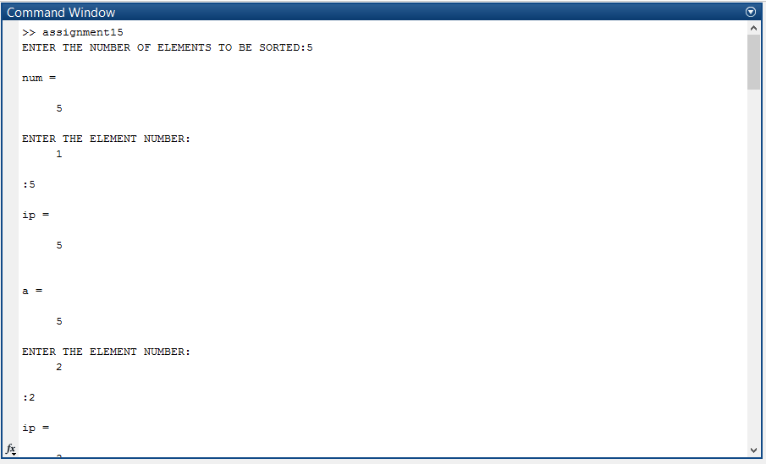

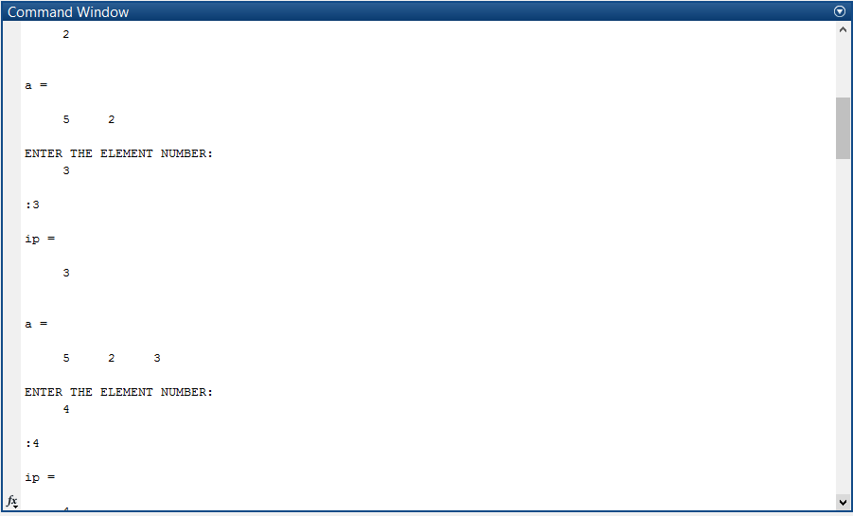

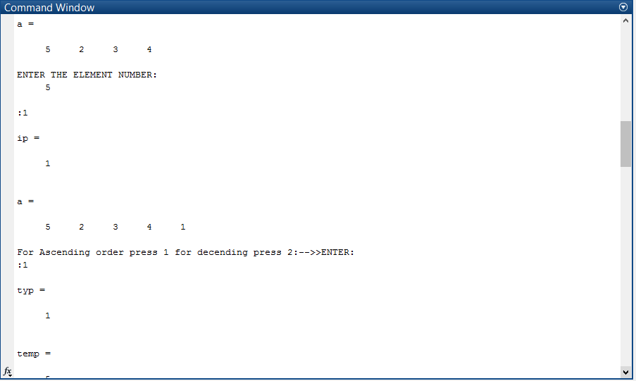

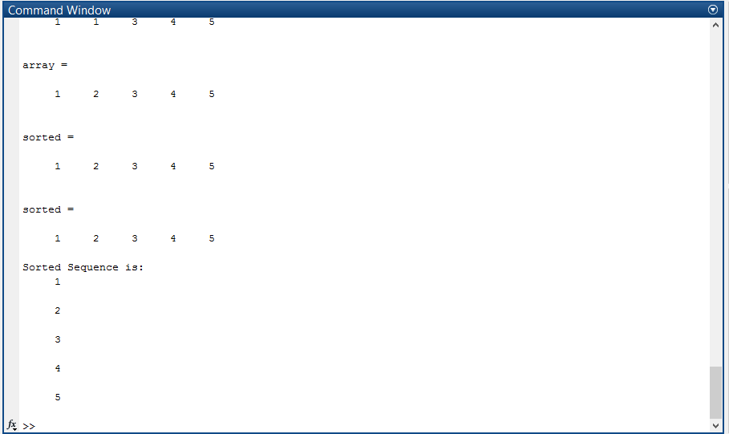

AIM 6:- Write a matlab program to check whether given number is prime or not.

Code:-

num=input('ENTER NUMBER TO CHECK WHEATHER IT IS PRIME OR NOT::');

count=0;

for i=1:num

if mod(num,i)==0

count=count+1;

else

x=0;

end

end

if count==2

disp('IT IS A PRIME NUMBER.')

else

disp('IT IS NOT A PRIME NUMBER.')

end

Output:-

